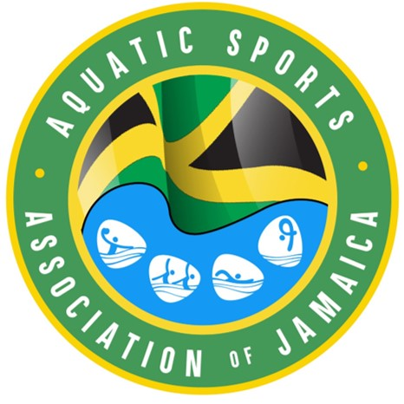
Member Feedback on Areas for Constitutional Change
The Governance Committee of the Aquatic Sports Association of Jamaica (ASAJ) has been tasked with preparing a revised constitution. Member Clubs and individual members are invited to provide feedback on areas where you believe changes are required. Please complete the table below, identifying any problems or weaknesses with the existing constitution and your proposed changes. This includes By-laws and related rules and policies. Please ensure that your submission is clearly identified so that engagement can occur as we all work to improve the ASAJ’s governance structure.
Thank you for your time, effort and contribution.

Respondent Information
Name of Respondent
Club
Role

Feedback Table
 | Current Problem/Weakness  (If referring to a specific section of existing Constitution, please identify) | Proposed Change and Rationale/Benefit | Priority (High/  Medium/  Low)
1
2
3
4
5

